Software Engineering

**MODULE:**

SE – Overview of It Industry

1. What is software? What is software engineering?

Software is set of instructions, programs used to

Operate computers and execute specific task.

Software is a collection of programs.

Software engineering:

Software engineering is the process of developing, designing, maintaining and testing computer programs.

Software engineering is build a code to solve

Specific task

1. Explain types of software.

**There is a two main types of software is:**

* **System software**
* **Application software**

**System software:**

**System software written in low level assembly language or machine code.**

**System software runs independently.**

**Necessary for the system function.**

**Application software:**

**Application software written in higher level assembly language like python or java script.**

**Needs system software to run.**

**Not necessary for the system function.**

1. What is SDLC? Explain each phase of SDLC

**SDLC stands for software development life cycle.**

**Phase of SDLC:**

* **Planning**
* **Analysis**
* **Design**
* **Implementation**
* **Testing**
* **Maintenance**

**Planning: the first step of SDLC it is planning process.**

**Analysis: the second step of SDLC**

**It is switch to the research and analysis.**

**Design: third step of SDLC for development project and designing.**

**Implementation: it is fourth step of SDLC**

**For implementation process.**

**Testing: fifth step of SDLC where developers test their programing.**

**Maintenance: the maintenance step in**

**SDLC is ongoing process for upgrades, repairs and maintain.**

1. What is Use case Diagram? Create a use-case on bill payment on paytm.

Use case diagram is a visual representation of the interactions between users and a system.

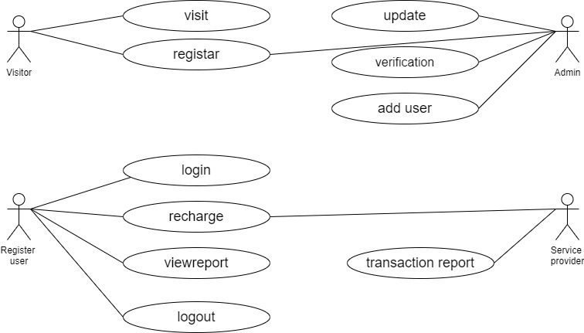

Use Case Diagram Payment Of Paytm

1. What is Flow chart? Create a flowchart to make addition of two numbers.

**Flowchart** are nothing but the graphical representation of the data or the algorithm for a better understanding of the code visually. It displays step-by-step solutions to a problem, algorithm, or process.

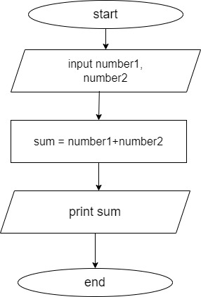

1. What is DFD? Create a DFD diagram on Flipkart

Data flow diagram (DFD) is a visual representation of how data flows through a system. We can use a DFD to analyse existing systems or create new ones.

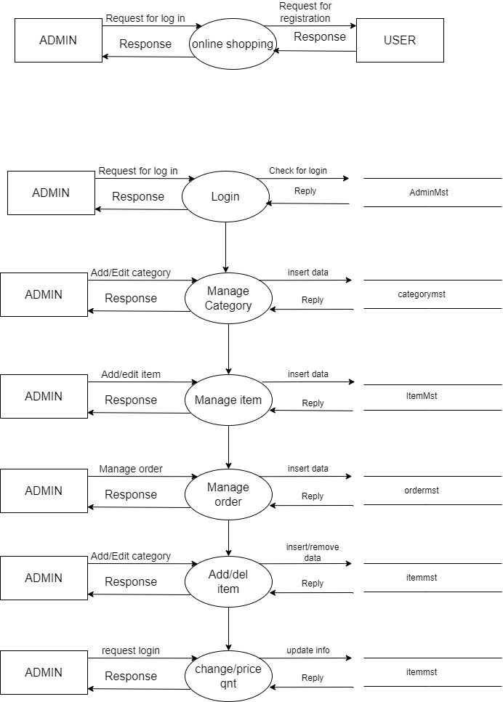

**Admin side DFD**

Admin side DFD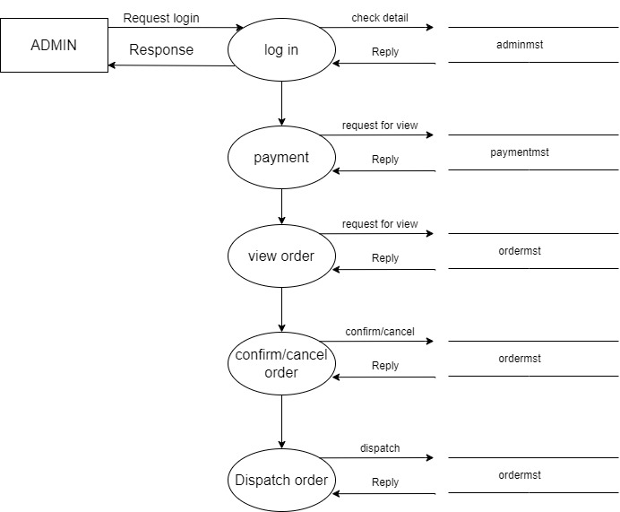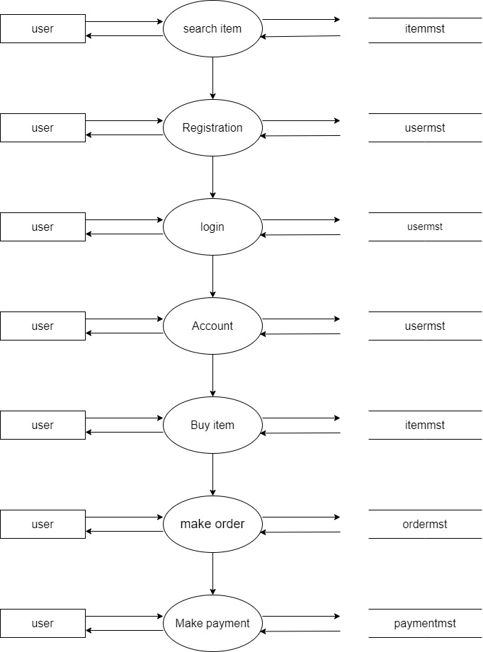

**User side DFD**

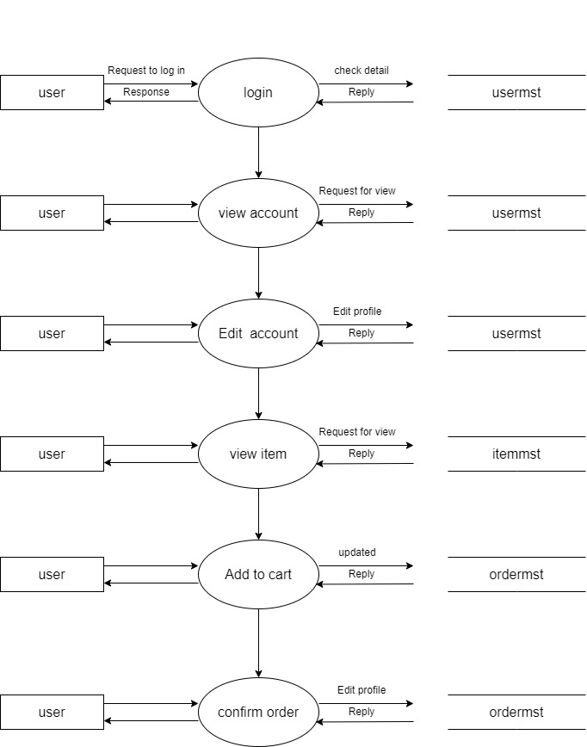

User side DFD